. INTRODUCTION

Project Overview

This project analyzes the number and distribution of toy manufacturers across US states from 2005 to 2016.
The goal is to provide insights into manufacturing trends using MySQL and Tableau.

Purpose

The purpose is to identify state-wise and year-wise manufacturing trends and visualize the insights using interactive dashboards.

. IDEATION PHASE

Problem Statement

Toy manufacturers collect a lot of data, but understanding it can be difficult. This project uses Tableau to turn complex toy data into easy, clear visuals to help improve sales, production, and decision-making.

Empathy Map Canvas

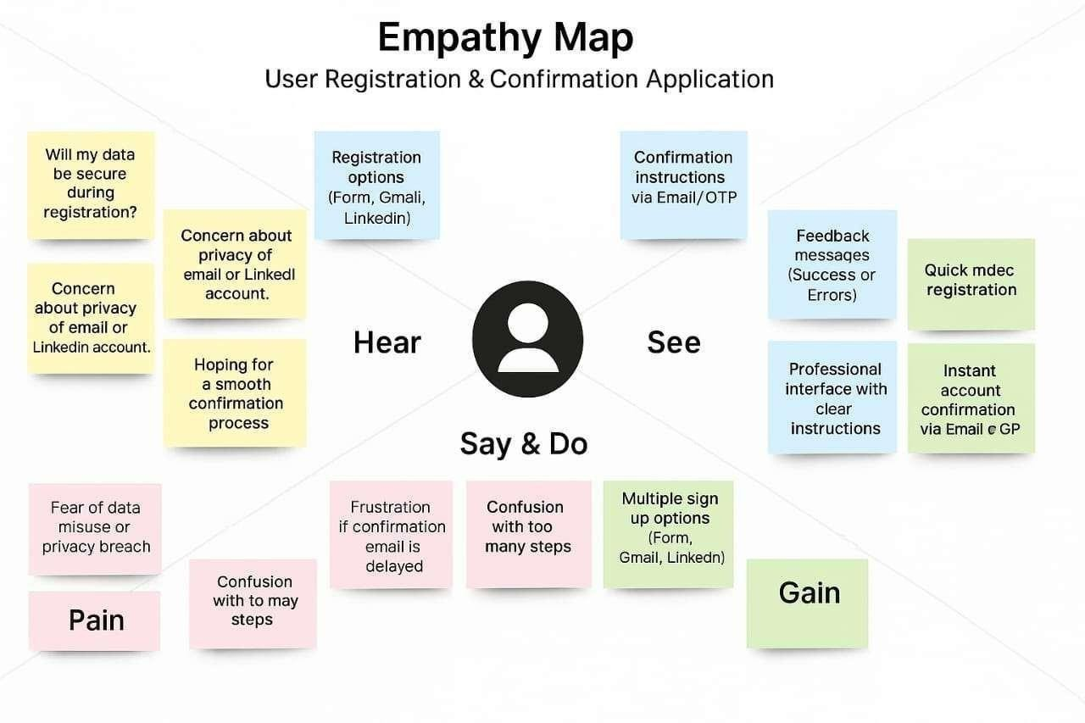

Brainstorming

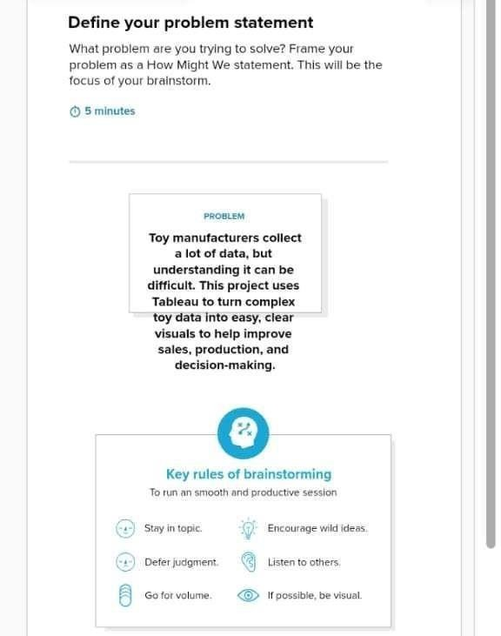

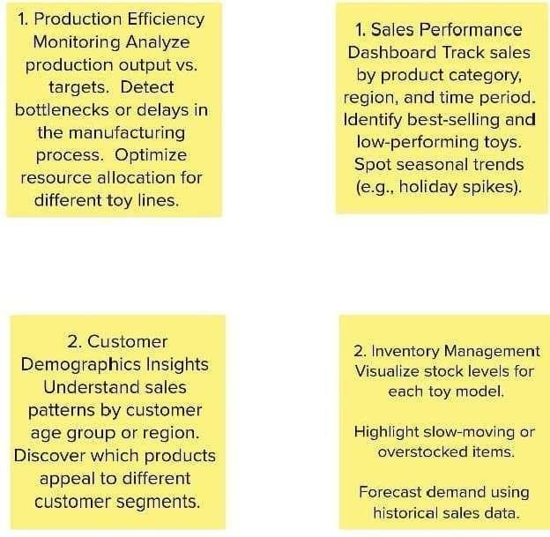

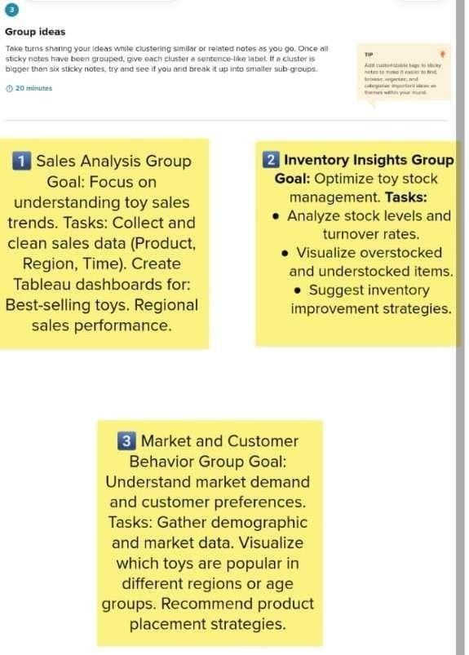

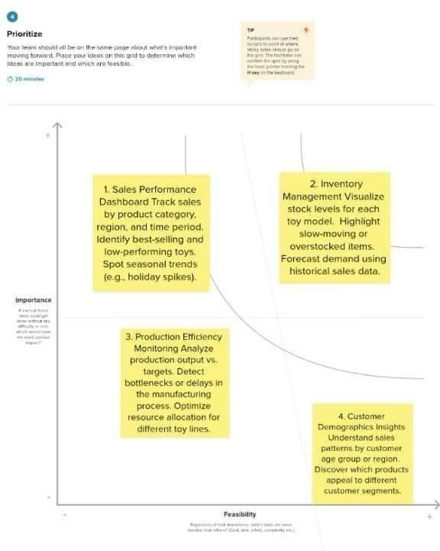

. REQUIREMENT ANALYSIS

Customer Journey map

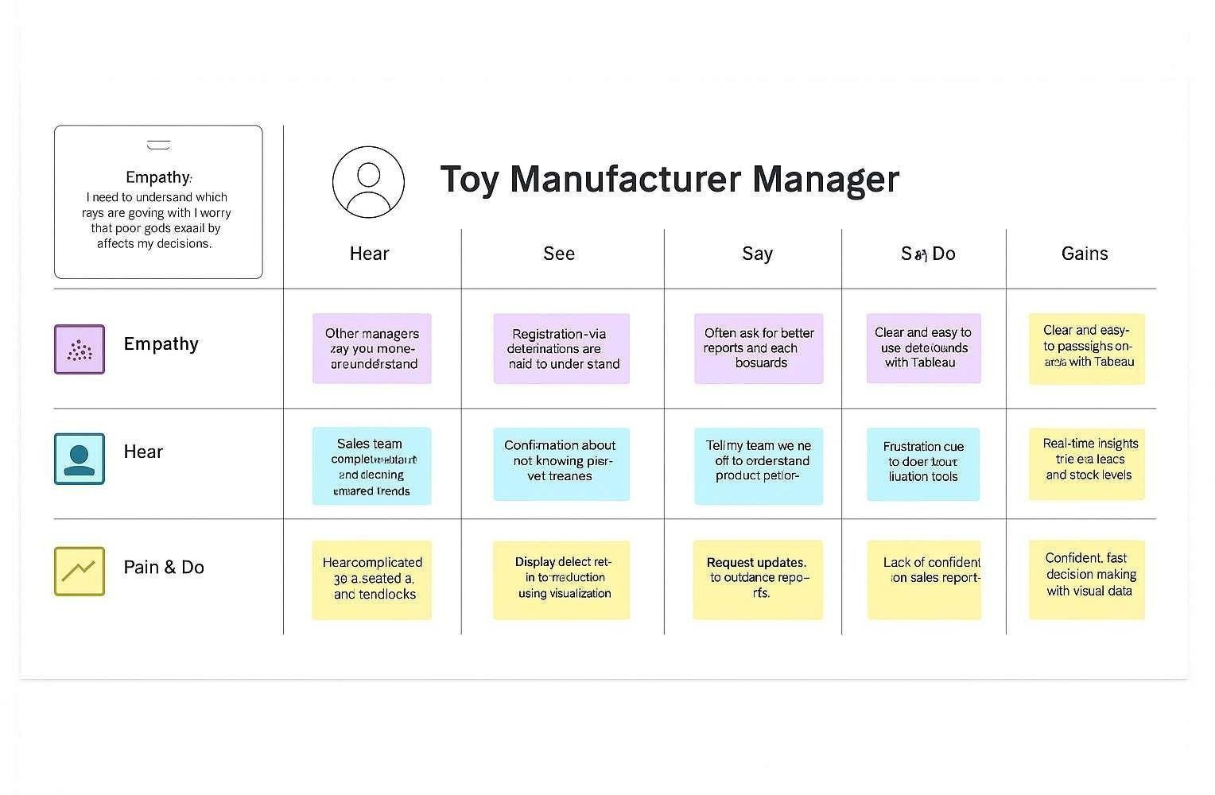

Solution Requirement
Functional Requirements:
The following are the functional requirements of the proposed solution.
FR No. | Functional Requirement (Epic) | Sub Requirement (Story / Sub-Task)
FR-1 | Data Upload | Upload toy sales and production data via CSV or  Excel file
FR-2 | Data Visualization | Generate interactive dashboards using Tableau
FR-3 | Sales Trend Analysis | Provide visual reports of sales trends and peak seasons
FR-4 | Defect Rate Insights | Display defect rates in production using visualization
FR-5 | Export Reports | Export visual reports in PDF and image formats
Non-functional Requirements:
Following are the non-functional requirements of the proposed solution.
NFR No. | Non-Functional Requirement | Description
NFR-1 | Usability | Easy-to-use interface with drag-and-drop features
NFR-2 | Security | Secure login with password protection, role- based access
NFR-3 | Reliability | Ensure system handles large datasets without crashing
NFR-4 | Performance | Dashboards load within 3 seconds for optimal performance
NFR-5 | Availability | System available 99.9% of the time, minimal downtime
NFR-6 | Scalability | Support increased data volume as company grows

Data Flow Diagram

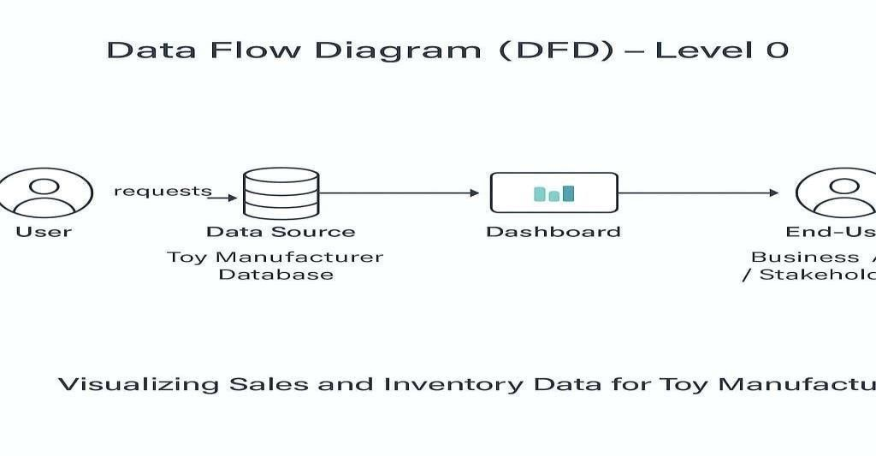

Technology Stack

Table-1 : Components & Technologies:
S.N o | Component | Description | Technology
1 | User Interface | Tableau Dashboards viewed by users | Tableau, Tableau Public
2 | Application Logic-1 | Data Preparation for Visualization | Tableau Prep, Python (if applicable)
3 | Application Logic-2 | Sales, Inventory, and Trends Analysis  Logic | Tableau Calculations, Expressions
4 | Database | Store Sales, Inventory, and Customer  Data | MySQL, CSV, Excel, Google  Sheets
5 | Cloud Database | Cloud-based storage for scalability | AWS RDS, Google Cloud SQL  (Optional)

6 | File Storage | Store raw data files, reports | Google Drive, Cloud Storage
7 | External API-1 | Integration with sales platforms (if applicable) | Shopify API, Google Analytics API
8 | External API-2 | Integration with market trend data  (optional) | Market Research APIs (Optional)
9 | Machine Learning Model | Predictive sales trends and inventory forecasting | Basic ML with Tableau Extensions or Python
10 | Infrastructure (Server/Cloud) | Hosting Tableau dashboards and databases | Local Server or Tableau Online
Table-2: Application Characteristics:
S.No | Characteristics | Description | Technology
1 | Open-Source Frameworks | Using Tableau Public and open-source data processing tools | Tableau Public, Python
2 | Security Implementations | Access control for dashboard sharing, data security measures | Password Protection, Cloud  Security
3 | Scalable Architecture | Cloud deployment for handling large datasets if needed | AWS, Google Cloud (Optional)

. PROJECT DESIGN

Problem Solution Fit

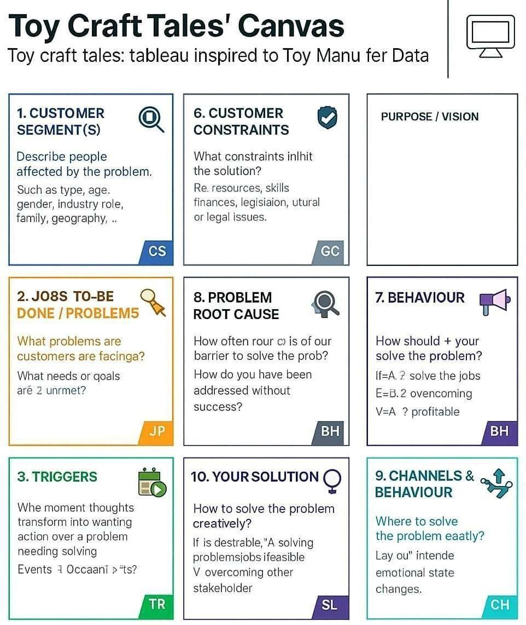

Proposed Solution

S.No. | Parameter | Description
1 | Problem Statement  (Problem to be solved) | Toy manufacturers collect a lot of data but understanding it can be difficult. This project uses Tableau to turn complex toy data into easy, clear visuals to help improve sales, production, and decisionmaking.
2 | Idea / Solution description | A Tableau-powered interactive dashboard system that visualizes key toy industry metrics – including demand trends, age group preferences, and stock levels – for real-time decision-making.
3 | Novelty / Uniqueness | Combines storytelling with data through “Toy Craft Tales” – a narrative-based approach that helps nontechnical users interpret complex datasets intuitively.
4 | Social Impact / Customer Satisfaction | Increases efficiency in toy production, reduces waste, and aligns products with children’s interests – ultimately leading to higher satisfaction for both customers and manufacturers.
5 | Business Model (Revenue Model) | Subscription-based model for manufacturers and retailers; freemium version with limited dashboards, with additional premium analytics and customization for enterprise clients.
6 | Scalability of the Solution | The solution can scale across global markets and be adapted for various toy segments, from educational toys to collectibles, with multilingual and regional data support.

Solution Architecture

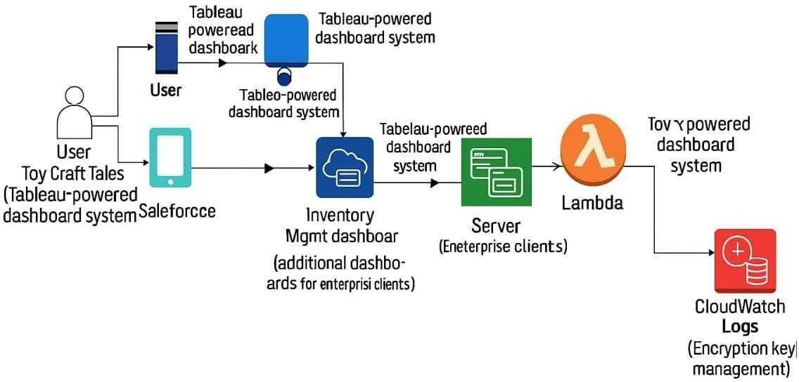

PROJECT PLANNING & SCHEDULING

Project Planning

Sprint | Functional  Requirement  (Epic) | User Story  Number | User Story / Task | Story Points | Priority | Team  Members
Sprint-1 | Data Upload | USN-1 | As a Data  Analyst, I can upload sales and inventory data in CSV format | 3 | High | Team A
Sprint-1 | Dashboard  View | USN-2 | As a Data Analyst, I can view interactive dashboards in  Tableau | 2 | High | Team A
Sprint-2 | Trend Analysis | USN-3 | As a Manager, I can analyze seasonal sales trends | 3 | Medium | Team B
Sprint-2 | Inventory  Monitoring | USN-4 | As a  Warehouse  Staff, I receive alerts for low inventory levels | 2 | High | Team B
Sprint-3 | Report Export | USN-5 | As a Manager, I can export dashboards as PDF/image | 1 | Medium | Team C

Sprint | Total Story Points | Duration | Sprint Start  Date | Sprint End Date | Story Points  Completed
Sprint-1 | 5 | 5 Days | 11 June 2025 | 15 June 2025 | 5
Sprint-2 | 5 | 5 Days | 16 June 2025 | 21 June 2025 | 5
Sprint-3 | 1 | 3 Days | 22 June 2025 | 24 June 2025 | 1

. FUNCTIONAL AND PERFORMANCE TESTING

Performance Testing

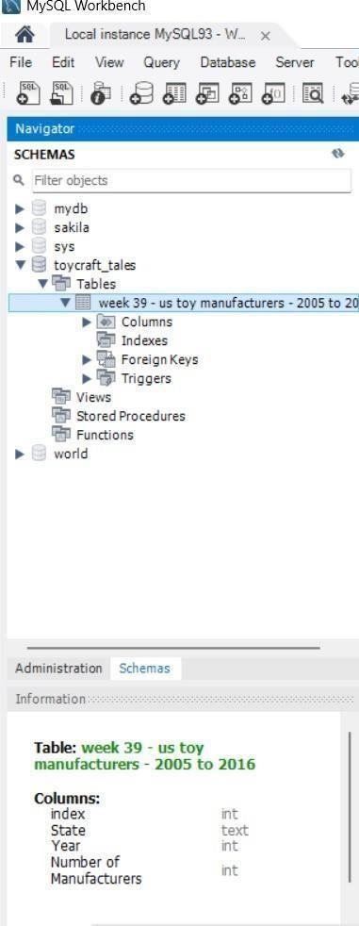

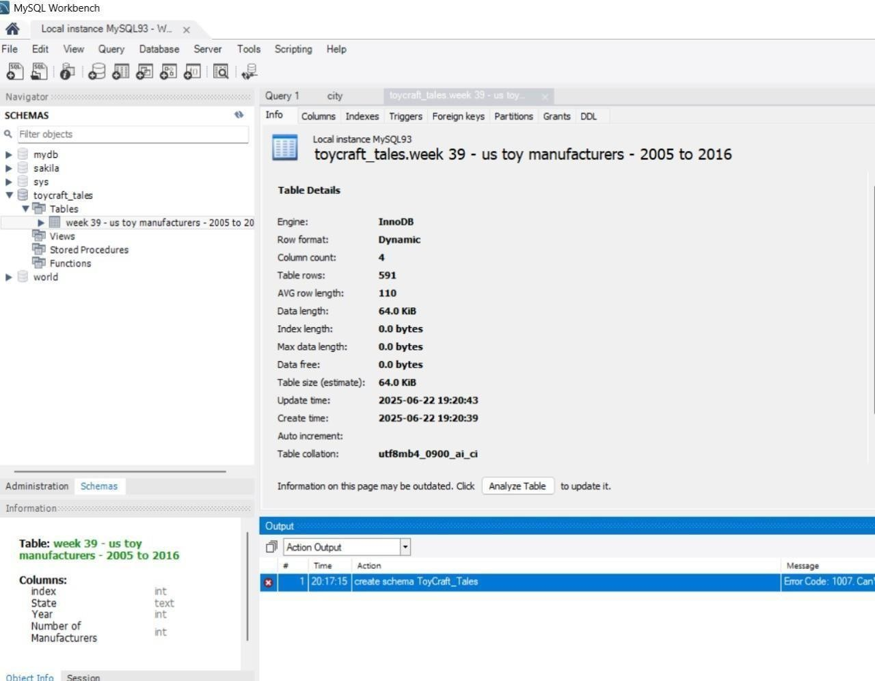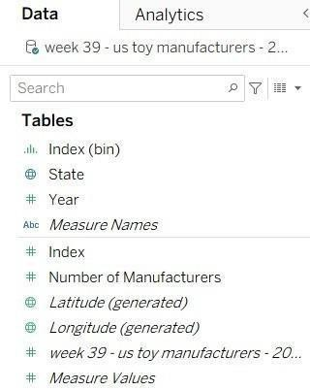

. RESULTS

Output Screenshots

Below are the Tableau visualization results based on the dataset:

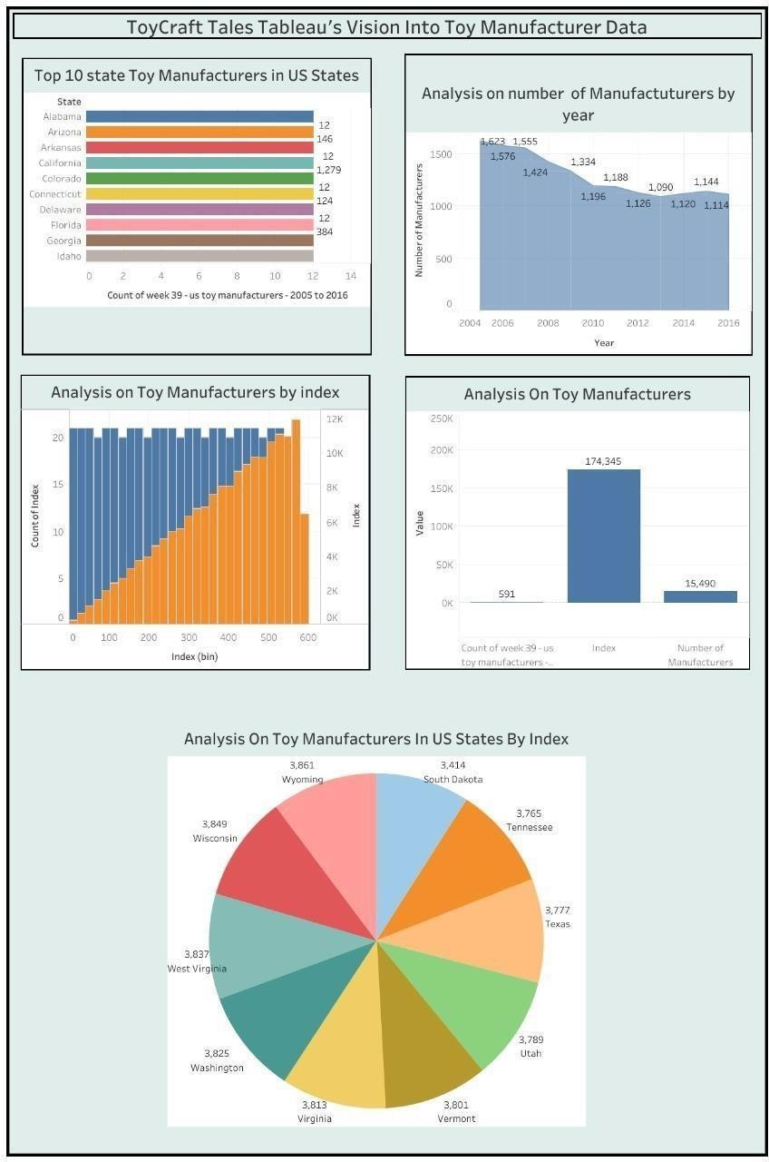

. ADVANTAGES & DISADVANTAGES

Advantages:

Easy Integration: Tableau can integrate with databases like MySQL, Google Sheets, or Cloud Storage where user data is stored, allowing seamless reporting.
User-Friendly Interface: Non-technical stakeholders can easily interpret the reports and

KPIs related to registration, confirmation success rates, etc.

Real-Time Data Monitoring: Tableau enables real-time monitoring of user activities such as registrations through different channels (Form, Gmail, LinkedIn).
Disadvantages:

Cost Factor : Tableau licenses (especially Tableau Server or Tableau Online) can be expensive for small teams or projects with a limited budget.

Limited Interactivity with Core System : Tableau cannot trigger real-time actions like sending confirmation emails or OTPs—it can only report these processes.

Dependency on Data Source : Real-time accuracy depends on how well your databases or APIs integrate with Tableau; poor setup can delay reporting.

. CONCLUSION

This project uses Tableau to convert complex toy sales and inventory data into simple, interactive dashboards. It helps the company track sales trends, manage stock, and make better decisions quickly. Though Tableau is not a system development tool, it is ideal for data visualization and business insights, making operations more efficient.

. FUTURE SCOPE

Advanced Predictive Analytics: Integrate machine learning models with Tableau to predict toy sales trends, seasonal demand, and customer preferences.

Real-Time Data Integration: Connect Tableau directly to live data sources (e.g., sales platforms, inventory systems) for real-time dashboards and alerts.
Mobile Dashboard Access: Expand Tableau reports for mobile devices, enabling managers to track sales and stock anytime, anywhere.S

Submitted By:
Team Id:LTVIP2026TMIDS41952
Team leader Name: U. Sunil yadav
Name : thanuku Ambika charan

ToyCraft Tales - Project Report

